Genetic Algorithms: Rosenbrock

Computer Intelligence



## 

## Andrey Núñez

## Eric Walzthöny

### Barcelona, 20th of December, 2021

**Introduction:**

In this laboratory we experimented with Genetic Algorithms, specifically we looked at the Rosenbrock function. Per the definition it is “.. a non-convex function used as a performance test problem for optimization algorithms.”, here we used it to determine the global minimum, finding the optimal parameters for:

* Crossover Fraction
* Generation Number
* Population Size
* Selection Function
* Initial Range

**Methods: How we chose the parameter combination?\***

In short, it was done by brute-force. The parameters were chosen by implementing the given function for the parameters, and iterating for 100 times, and the average was then saved in an array. This was then plotted in order to find the optimal value. The optimal value in this case, was the lowest point on the graph, as it would lead to the best fval value.

For some parameters such as “Population Size” and “Initial Range” were chosen differently. For the Population Size, we saw that the gradient of the line did not change and went to a maximum of 50, which is the default value in the function. We found that the range of values [5, 50] would give the lowest Fitness Value. Whilst for the Initial Range (which in the graph is seen as the upper limit), was seen to be [1;2], this, as seen on the Population Size as well, gave the lowest Fitness Values for the Fitness Function.

**Results:**

Below we can see the graphs for the defined parameters, which show the values after the 100 iterations, and using the mean of these values. In Graph 1, we can see the Crossover Function, and see that there are two minimum values, at about 0.44 and then again at 0.55.

Meanwhile in Graph 2, we can see the Generation Number gives the lowest Fval value when it is at about 70. In addition, Graph 3 shows the Population Size, since there is a range at which it [N or size] does not affect the Fval value, any value between the range [5,50] can be selected, at least in our case this was the methodology. 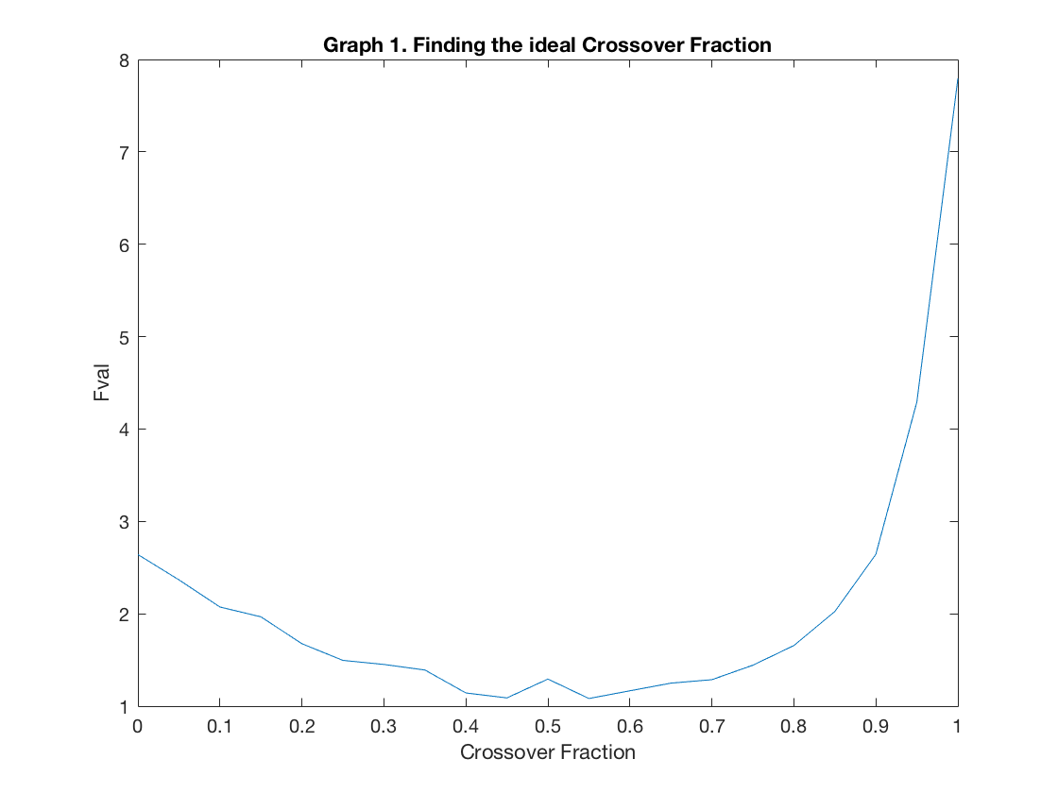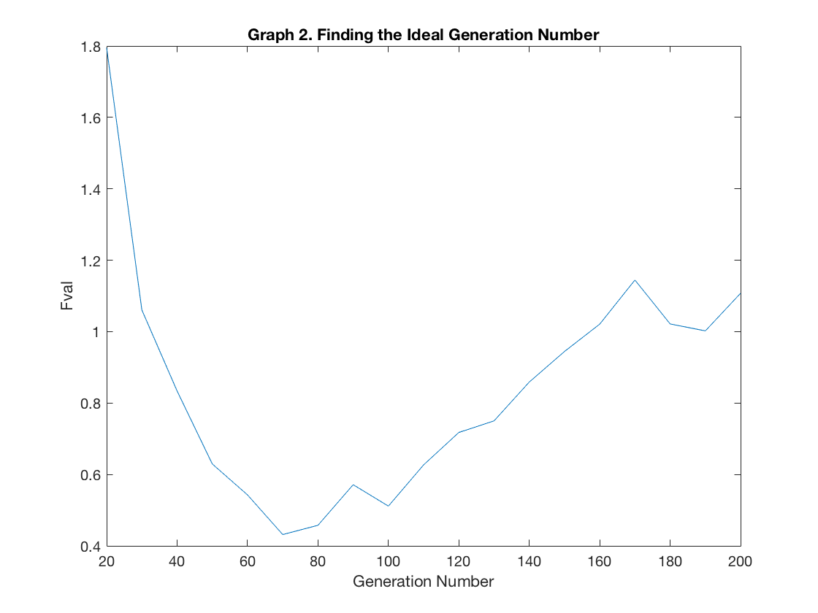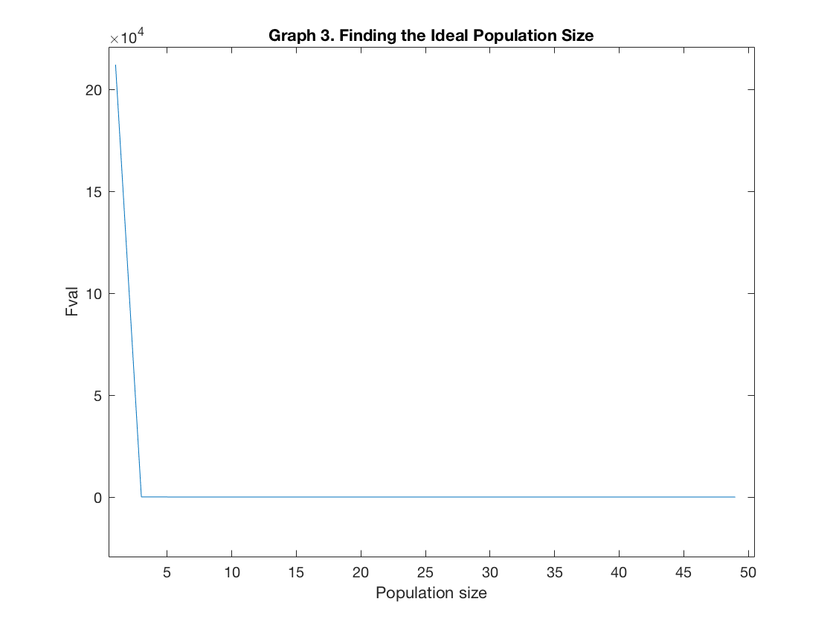

Lastly, the two other parameters Selection Function and Initial Range, can be seen in Graph 4 and 5 (shown below). For the Selection Function, the one with the highest Fitness Value was chosen, as it would give the best result for the Rosenbrock function.

On the other hand, For the initial range we see that the lowest values for the Fitness Value are in between [0,5], therefore we can use the lower limit and upper limit as follows:

*For (lower_range) in range(0, 5):*

*upper_range = lower_range + 1*

*Initial_range = (lower_range, upper_range)*

*If upper_range > 5:*

*upper_range = 5*

*lower_range = upper_range - 1*

*Initial_range = (lower_range, upper_range)*

This allows us to be more flexible with the ranges that we can use, since we’re able to have *N-1* ranges (4). In our experiment, this did not affect the final result of the Rosenbrock graph. 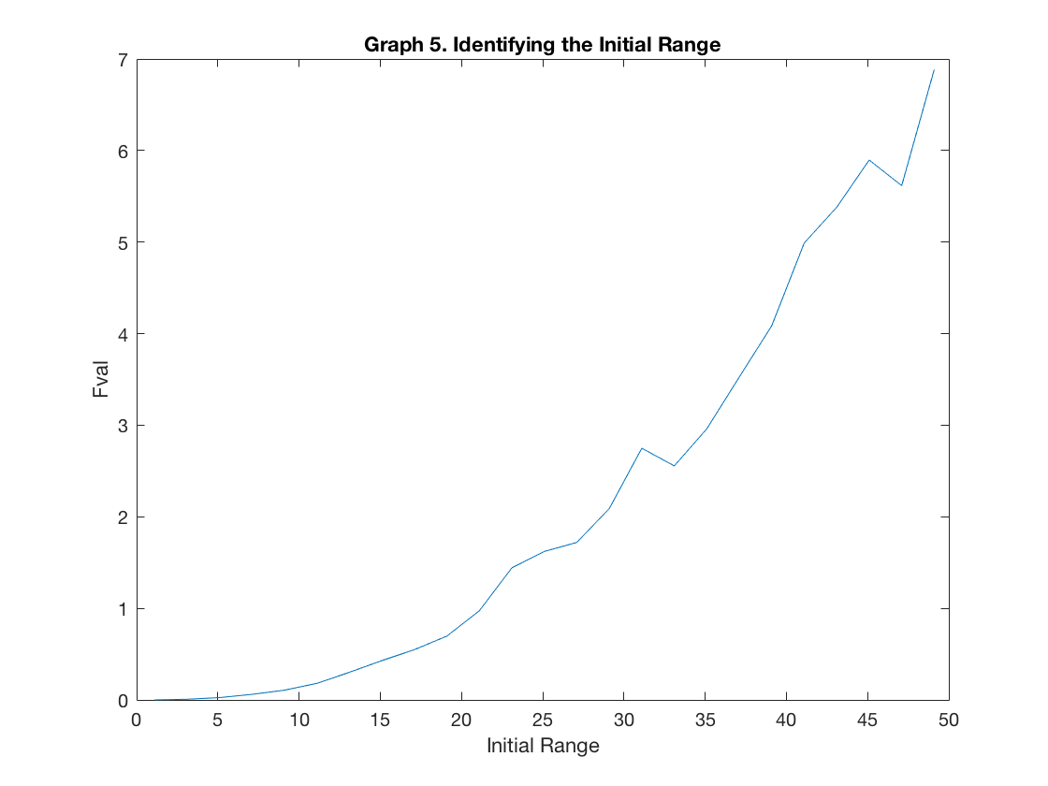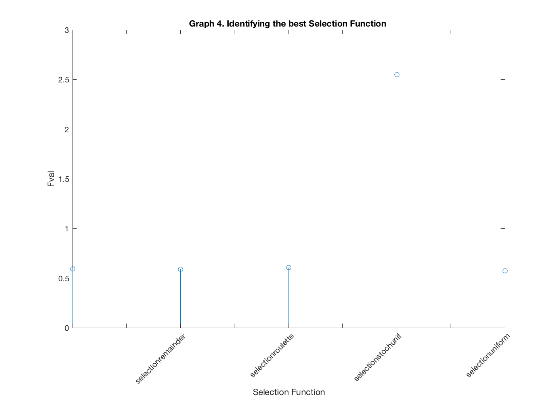

Finally, in order to determine the global optimum for the Rosenbrock Banana (or Valley) function, we use the aforementioned parameters to graph the Contour and Response curve, as seen in Graph 6 and 7 below..

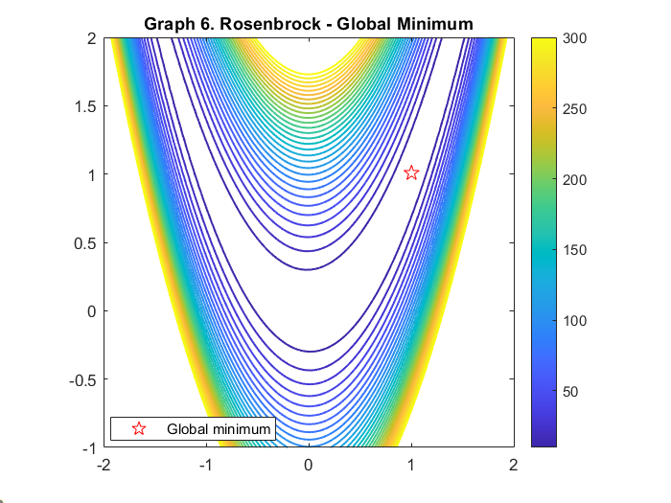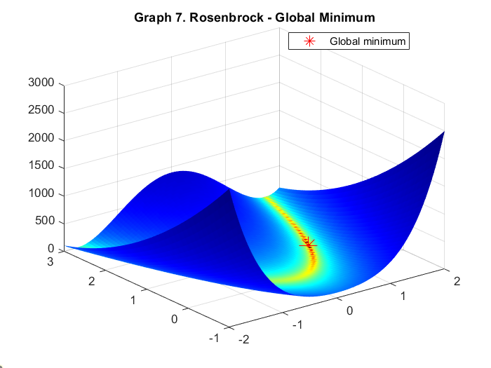

From the Contour plot and the Banana / Valley plot of the Rosenbrock function, Graph 6 and 7 above, we can answer the question of *“where is the global minimum?”* from this we can see that in both it is at (1,1), with the parameters that we used for the experiment.

In the Rosenbrock function, the global minimum is found inside a long, narrow parabolic valley [1]. Finding this valley is not the hard part, the issue is finding the convergence. To answer the question “*which is the global minimum?”* we show the following:

The function is defined by: $f(x,y) = (a-x)^{2} + b(y-x^{2})^{2}$…Eq1…. [1]

Where its global minimum is at $(x,y) = (a, a^{2}), where f(x,y) = 0$….Eq2...[1,2]

In this case, the Rosenbrock function converges at the defined solution [1], however, there are other cases when the value of *a = 0* that the function becomes symmetric such that the minimum is at the origin.

**Discussion:**

In this experiment we found the different parameters for the Rosenbrock function. The parameters that were found, albeit random in initiation (setting no initial seed), were found to be similar to the solutions for the convergence of the function. In this setting, the parameters gave the global minimum at the given solution (1,1) as seen in Eq1 and Eq2. We found that for some parameters there are ranges which allow some flexibility at the time of solving this problem. Overall, we saw that the combination of parameters we found gave expected results with the literature.

*\* A note regarding the setup of the files*, there are two files 1) genetic_algorithms.m and the other is 2) Rosenbrock_final.m, in the first file, we cycle through all the parameters to find the best value for each parameter, whilst in the latter, we use the resulting parameters to run the Rosenbrock function.

**Bibliography**

[1] H. H. Rosenbrock, An Automatic Method for Finding the Greatest or Least Value of a Function, *The Computer Journal*, Volume 3, Issue 3, 1960, Pages 175–184, <https://doi.org/10.1093/comjnl/3.3.175>

[2] "Generalized Rosenbrock's function". Retrieved 2008-09-16.<https://docs.scipy.org/doc/scipy-0.14.0/reference/tutorial/optimize.html#unconstrained-minimization-of-multivariate-scalar-functions-minimize>